AIR QUALITY MONITORING USING IOT

Team :

|  |  |
| --- | --- |
| S.No | Teammembers |
| 1. | Raja.M |
| 2. | Surya.R |
| 3. | Chandru.s |
| 4. | Ashok.s |
| 5. | Sachin.v |
| 6. | Balaji.p |

INDRODUCTION:

Every developer on their journey to be a master web developer learns HTML in the first place. After being handy with HTML, one proceeds to the next step of learning, which is CSS. The modern-day webpages are so robust and made of advanced technology. Therefore, the question here is – Is HTML and CSS enough to create a website?

The short answer here is Yes.

If you require a static website that displays text, images, links, and buttons beautifully, HTML and CSS are more than enough to get you a good-looking landing page or even a business website. Let’s start learning the core concepts of HTML and CSS, and at the end of this tutorial, you will be able to create a beautiful website by just using HTML and CSS.

**Understanding and using HTML Elements**

In HTML, elements are the building blocks for an HTML document. It usually contains an opening tag, a closing tag, and the content between them. It helps browsers to interpret in classifying the content, such as headings, images, paragraphs, and more.

<em> This is an emphasized text </em>

In this example, it tells the browser to interpret and render this HTML element as an emphasized text.

**Using Inline-level and Block-level Elements in HTML**

Block-level elements in HTML are those elements that always start on a new line and occupy the complete width of the screen. Some popular block-level elements are, <p>, <div>, <table>, and more.

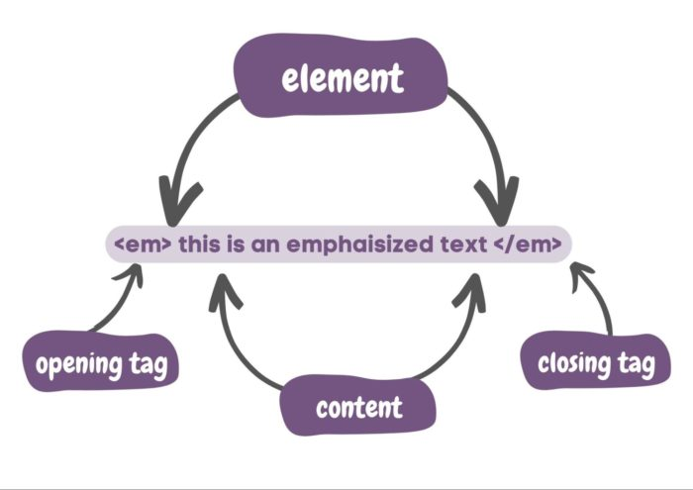

Top of Form

Bottom of Form

[Categories](https://www.browserstack.com/guide/build-a-website-using-html-css)

[Home](https://www.browserstack.com/) [Guide](https://www.browserstack.com/guide)

# **build a website using HTML and CSS**

By Mohit Joshi, Community Contributor - March 10, 2023

Every developer on their journey to be a master web developer learns HTML in the first place. After being handy with HTML, one proceeds to the next step of learning, which is CSS. The modern-day webpages are so robust and made of advanced technology. Therefore, the question here is – Is HTML and CSS enough to create a website?

The short answer here is Yes.

If you require a static website that displays text, images, links, and buttons beautifully, HTML and CSS are more than enough to get you a good-looking landing page or even a business website. Let’s start learning the core concepts of HTML and CSS, and at the end of this tutorial, you will be able to create a beautiful website by just using HTML and CSS.

**Table of Contents**

* [How to build a website using HTML](https://www.browserstack.com/guide/build-a-website-using-html-css#toc0)
* [How to build a website using CSS](https://www.browserstack.com/guide/build-a-website-using-html-css#toc1)
* [How To Adjust the Content, Padding, Border, and Margins of an HTML Element With CSS](https://www.browserstack.com/guide/build-a-website-using-html-css#toc2)
* [How To Set Up Your CSS and HTML Website Project](https://www.browserstack.com/guide/build-a-website-using-html-css#toc3)
* [How To Create A Layout And Build A Website Using HTML And CSS](https://www.browserstack.com/guide/build-a-website-using-html-css#toc4)
* [How To Test A Website Before Going Live On Browserstack](https://www.browserstack.com/guide/build-a-website-using-html-css#toc5)
* [Frequently Asked Questions](https://www.browserstack.com/guide/build-a-website-using-html-css#toc6)

### **build a website using HTML**

You must be aware of all the basic concepts and techniques associated with HTML before compiling all of it to create a website using HTML and CSS. There are multiple actions you are going to perform while writing code in HTML.

**How To View the Source Code of an HTML Document?**

Every webpage on the internet uses HTML to structure its webpage and display it. To view the source code of any webpage, navigate to the webpage, right-click on the page and then select “view page source”. Moreover, you may use a keyboard shortcut CTRL + U or CMD + U to inspect the source code of any HTML document.

The source code of an HTML document will look something like this.

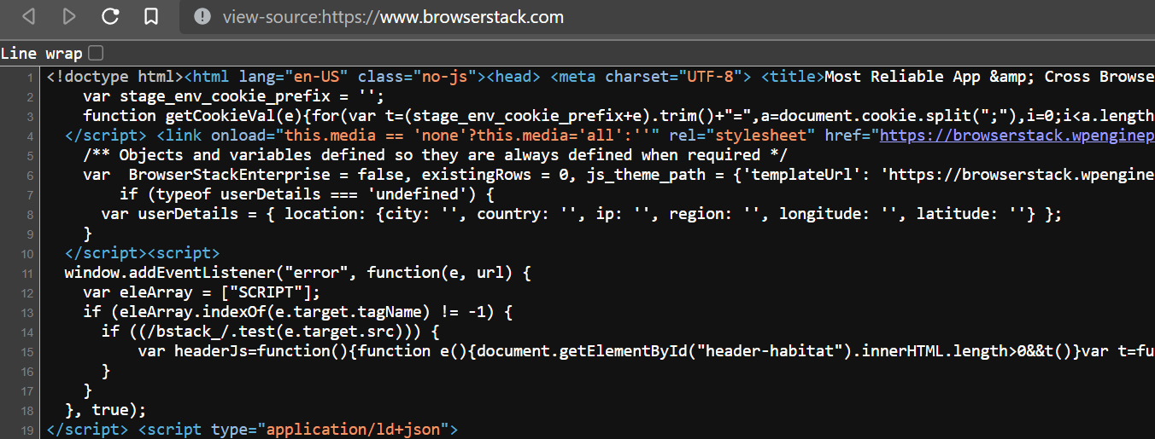

**Understanding and using HTML Elements**

In HTML, elements are the building blocks for an HTML document. It usually contains an opening tag, a closing tag, and the content between them. It helps browsers to interpret in classifying the content, such as headings, images, paragraphs, and more.

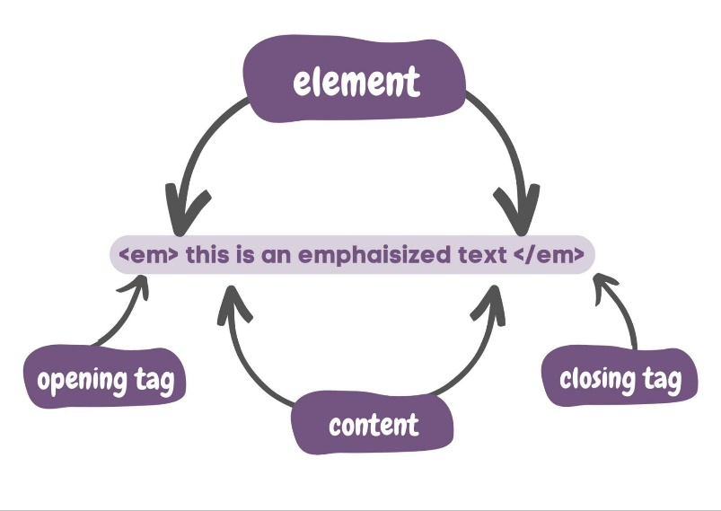

<em> This is an emphasized text </em>

In this example, it tells the browser to interpret and render this HTML element as an emphasized text.

**Using Inline-level and Block-level Elements in HTML**

Block-level elements in HTML are those elements that always start on a new line and occupy the complete width of the screen. Some popular block-level elements are, <p>, <div>, <table>, and more.

Inline-level elements are those elements that occupy only the necessary width and do not start on a new line.

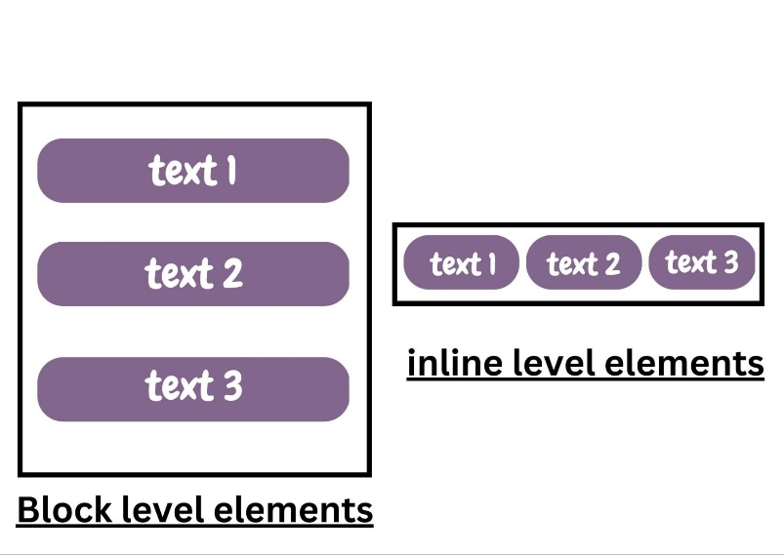

**How To Nest HTML Elements**

Nesting in HTML is to apply several HTML tags to a single content. In nesting, one element can be placed inside other elements. Another benefit of nesting in HTML includes improving the readability of your code for you and other developers.

Nesting in HTML will look something like this.

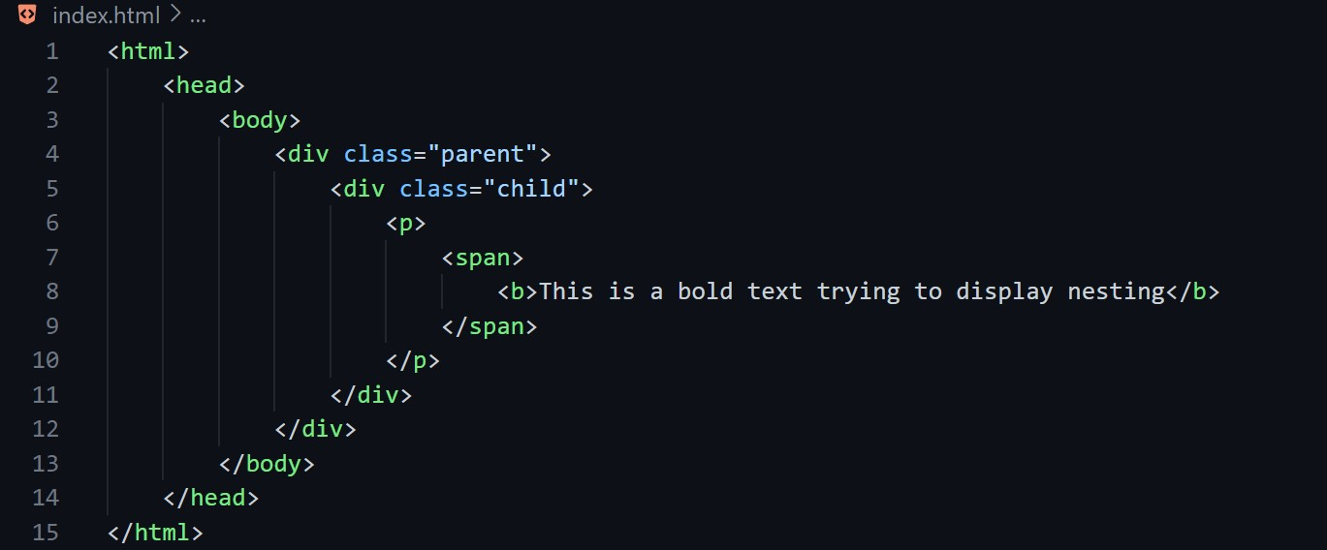

### **build a website using CSS**

**Understanding and Creating CSS Rules**

CSS rules also known as rulesets and are a combination of one or more CSS properties that you can apply to one or more HTML elements. It consists of a CSS selector and CSS properties. It determines what to style to a targeted HTML element.

div {

border-color: black;

font-size: 2rem;

}

In this instance, it creates a CSS rule targeting the div element and creating CSS properties, border–color, and font-size to be the style for the div element.

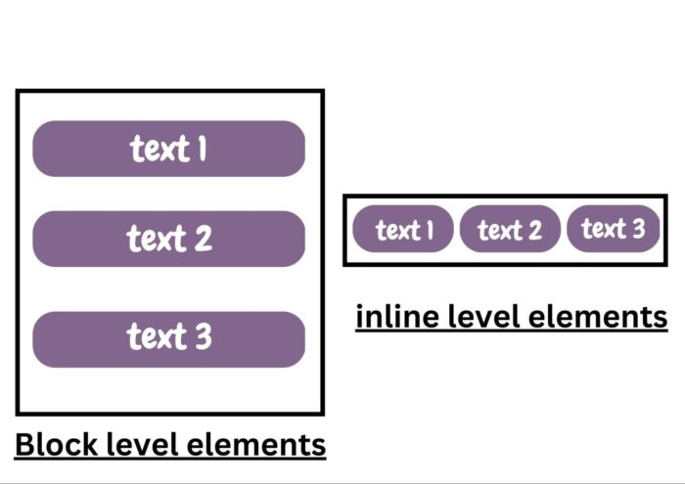Top of Form

[Categories](https://www.browserstack.com/guide/build-a-website-using-html-css)

[Home](https://www.browserstack.com/) [Guide](https://www.browserstack.com/guide)

**build a website using HTML and CSS**

By Mohit Joshi, Community Contributor - March 10, 2023

Every developer on their journey to be a master web developer learns HTML in the first place. After being handy with HTML, one proceeds to the next step of learning, which is CSS. The modern-day webpages are so robust and made of advanced technology. Therefore, the question here is – Is HTML and CSS enough to create a website?

The short answer here is Yes.

If you require a static website that displays text, images, links, and buttons beautifully, HTML and CSS are more than enough to get you a good-looking landing page or even a business website. Let’s start learning the core concepts of HTML and CSS, and at the end of this tutorial, you will be able to create a beautiful website by just using HTML and CSS.

**Table of Contents**

* [How to build a website using HTML](https://www.browserstack.com/guide/build-a-website-using-html-css#toc0)
* [How to build a website using CSS](https://www.browserstack.com/guide/build-a-website-using-html-css#toc1)
* [How To Adjust the Content, Padding, Border, and Margins of an HTML Element With CSS](https://www.browserstack.com/guide/build-a-website-using-html-css#toc2)
* [How To Set Up Your CSS and HTML Website Project](https://www.browserstack.com/guide/build-a-website-using-html-css#toc3)
* [How To Create A Layout And Build A Website Using HTML And CSS](https://www.browserstack.com/guide/build-a-website-using-html-css#toc4)
* [How To Test A Website Before Going Live On Browserstack](https://www.browserstack.com/guide/build-a-website-using-html-css#toc5)
* [Frequently Asked Questions](https://www.browserstack.com/guide/build-a-website-using-html-css#toc6)
* **build a website using HTML**

You must be aware of all the basic concepts and techniques associated with HTML before compiling all of it to create a website using HTML and CSS. There are multiple actions you are going to perform while writing code in HTML.

**How To View the Source Code of an HTML Document?**

Every webpage on the internet uses HTML to structure its webpage and display it. To view the source code of any webpage, navigate to the webpage, right-click on the page and then select “view page source”. Moreover, you may use a keyboard shortcut CTRL + U or CMD + U to inspect the source code of any HTML document.

The source code of an HTML document will look something like this.



**Understanding and using HTML Elements**

In HTML, elements are the building blocks for an HTML document. It usually contains an opening tag, a closing tag, and the content between them. It helps browsers to interpret in classifying the content, such as headings, images, paragraphs, and more.



<em> This is an emphasized text </em>

In this example, it tells the browser to interpret and render this HTML element as an emphasized text.

**Using Inline-level and Block-level Elements in HTML**

Block-level elements in HTML are those elements that always start on a new line and occupy the complete width of the screen. Some popular block-level elements are, <p>, <div>, <table>, and more.

Inline-level elements are those elements that occupy only the necessary width and do not start on a new line.



**How To Nest HTML Elements**

Nesting in HTML is to apply several HTML tags to a single content. In nesting, one element can be placed inside other elements. Another benefit of nesting in HTML includes improving the readability of your code for you and other developers.

Nesting in HTML will look something like this.



### **build a website using CSS**

**Understanding and Creating CSS Rules**

CSS rules also known as rulesets and are a combination of one or more CSS properties that you can apply to one or more HTML elements. It consists of a CSS selector and CSS properties. It determines what to style to a targeted HTML element.

div {

border-color: black;

font-size: 2rem;

}

In this instance, it creates a CSS rule targeting the div element and creating CSS properties, border–color, and font-size to be the style for the div element.

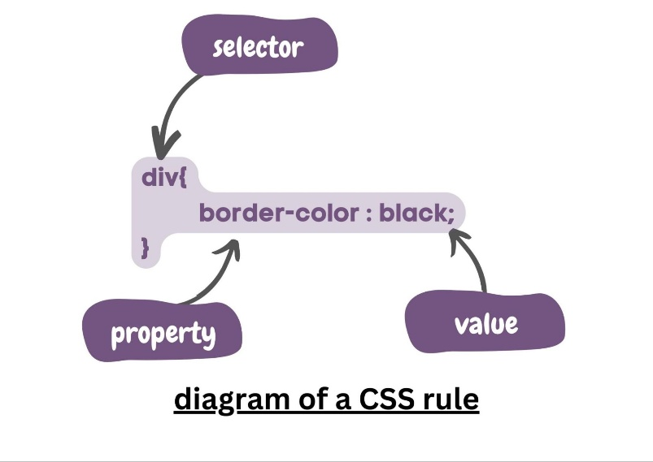

**Declaring Values For Multiple Properties In a CSS Rule**

In this section, let us learn how to declare values for multiple properties in a CSS rule. This is very helpful as it allows you to apply several style instructions to an HTML element all at once. In simpler words, for instance, if you want to apply border–color, font-size, and more to a div tag, you can do that all at once.

div {

border-color: brown;

font-size: 2rem;

font-family: 'Times New Roman';

}

**Style Images With CSS**

In this section, let’s learn how to style images with CSS such as adding a border to an image, adjusting its dimensions, and further specific CSS to our images in the webpage. First, add an image element in the HTML file.

***Javascript***

JavaScript (JS) is a lightweight interpreted (or just-in-time compiled) programming language with first-class functions. While it is most well-known as the scripting language for Web pages, many non-browser environments also use it, such as Node.js, Apache CouchDB and Adobe Acrobat. JavaScript is a prototype-based, multi-paradigm, single-threaded, dynamic language, supporting object-oriented, imperative, and declarative (e.g. functional programming) styles.

JavaScript’s dynamic capabilities include runtime object construction, variable parameter lists, function variables, dynamic script creation (via eval), object introspection (via for…in and Object utilities), and source-code recovery (JavaScript functions store their source text and can be retrieved through toString()).

This section is dedicated to the JavaScript language itself, and not the parts that are specific to Web pages or other host environments. For information about APIs that are specific to Web pages, please see Web APIs and DOM.

The standards for JavaScript are the ECMAScript Language Specification (ECMA-262) and the ECMAScript Internationalization API specification (ECMA-402). As soon as one browser implements a feature, we try to document it. This means that cases where some proposals for new ECMAScript features have already been implemented in browsers, documentation and examples in MDN articles may use some of those new features. Most of the time, this happens between the stages 3 and 4, and is usually before the spec is officially published.

Do not confuse JavaScript with the Java programming language — JavaScript is not “Interpreted Java”. Both “Java” and “JavaScript” are trademarks or registered trademarks of Oracle in the U.S. and other countries. However, the two programming languages have very different syntax, semantics, and use.

JavaScript documentation of core language features (pure ECMAScript, for the most part) includes the following:

The JavaScript guide

The JavaScript reference

For more information about JavaScript specifications and related technologies, see JavaScript technologies overview.

Bottom of Form

Top of Form

Bottom of Form

Top of Form

Bottom of Form